Q 1: Please count how many communication for each telephone numbers they call out;

<BR>

Hint: using count (\*) and group by 撥號

<BR>

use mydbase

select 撥號,count(\*) as 打了幾次

from TeleTable$

group by 撥號

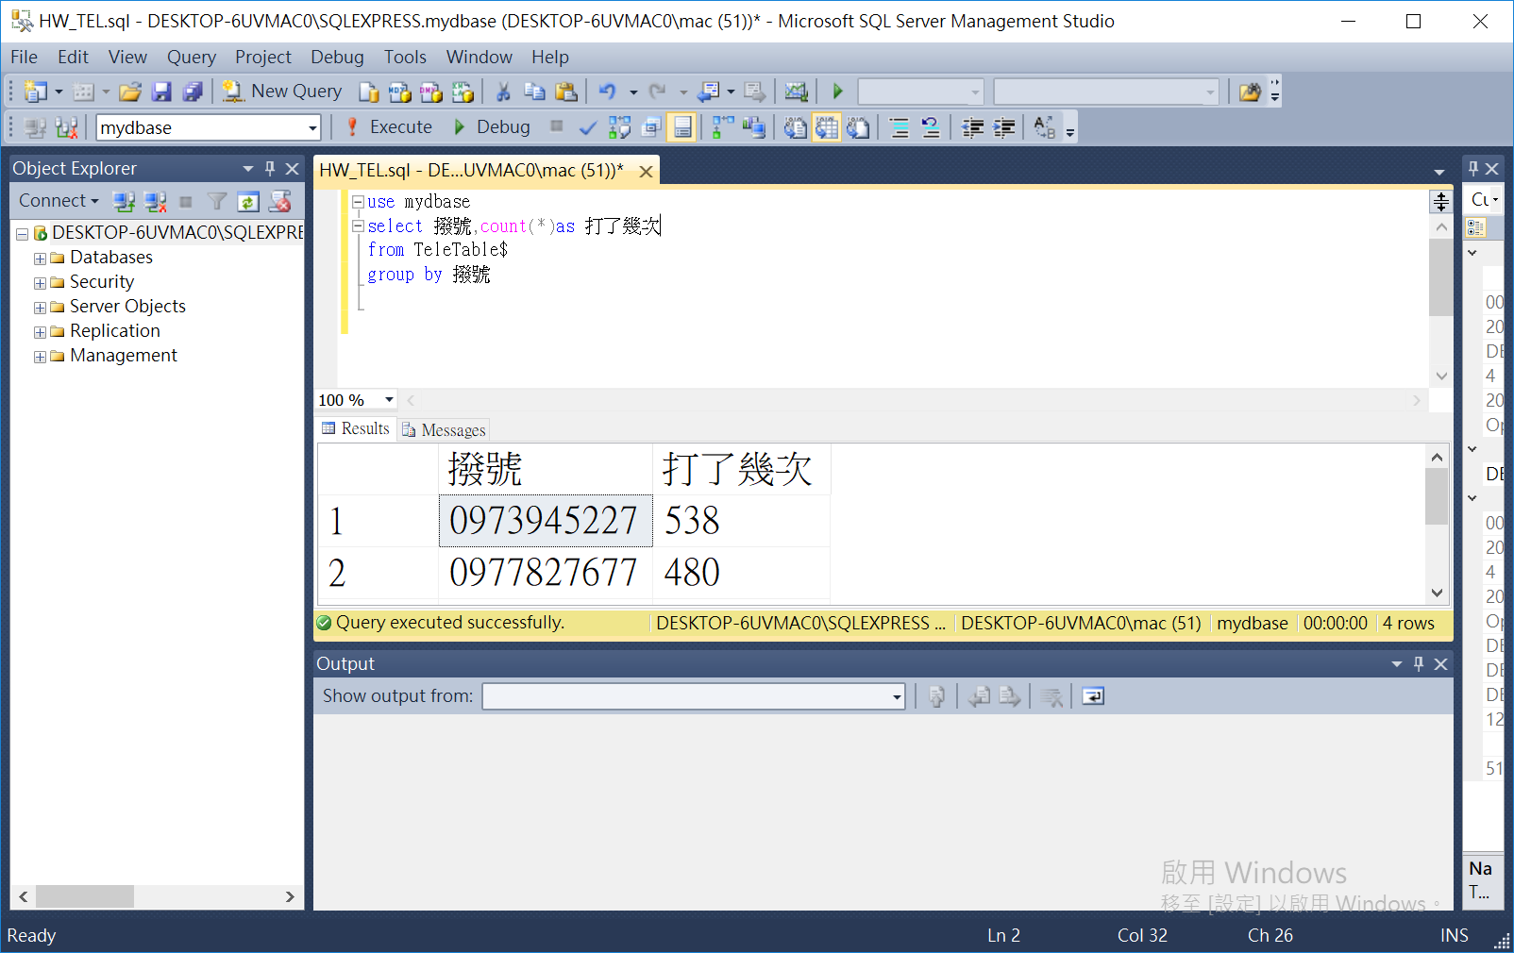

Q2: Please sum up how much communication time that each telecom company (i.e., 100, 101, 102, …) is consume.

<BR>

Hint: using sum(\*) and group by 電信

<BR>

use mydbase

select 電信,sum(時間) as 撥打時間

from TeleTable$

group by 電信

